

Shutter Speed Manual Video

Deployment Guide

Project Code: Shutter Speed Manual Video 2016

Document Code: ShutterSpeedManualVideo2016 _DeploymentGuide_v1.0.docx

**Ha Noi, Jan 2016**

Record of change

*A - Added M - Modified D - Deleted

|  |  |  |  |  |
| --- | --- | --- | --- | --- |
| Effective Date | Changed Items | A*, M, D | Change Description | New Version |
| 2015/ 01/ 09 | All | A | Create new | 1.0 |
|  |  |  |  |  |
|  |  |  |  |  |
|  |  |  |  |  |
|  |  |  |  |  |
|  |  |  |  |  |
|  |  |  |  |  |
|  |  |  |  |  |
|  |  |  |  |  |
|  |  |  |  |  |

Signature page

**Author：** Dang Van Hoach 2016/01/09

Name, Title Date

**Reviewer：** Nguyen Van Trang 2016/01/??

Name, Title Date

Name, Title Date

**Signature：** Dang Van Hoach 2016/01/09

Name, Title Date

Table of Contents

1. Features In This Release 3

1.1. Deployment Overview 3

1.2. Changes In This Release 3

2. Pre Deployment Steps And Deployment 4

2.1. Application Dependencies 4

2.2. Environments 4

2.3. Build source codes and execute application 4

1. Features In This Release

## Deployment Overview

This document guides how to build, execute Shutter Speed Manual Video on Android.

* 1. Changes In This Release

Add the guidelines of build, execute Shutter Speed Manual Video on Android.

# Pre Deployment Steps And Deployment

* 1. Application Dependencies

Android Studio IDE with built-in ADT (Android Developer Tools) latest version<Version 1.5.1 >

- Android SDK v23

- Android Build Tools v23.0.2

- Android Support Repository

<http://developer.android.com/intl/vi/sdk/index.html>

* 1. Environments

Windows 7 and Mac OSX.

* 1. Build source codes and execute application

This App uses the Gradle build system. To build this project, use the

"gradlew build" command or use "Import Project" in Android Studio.

Import folder projects

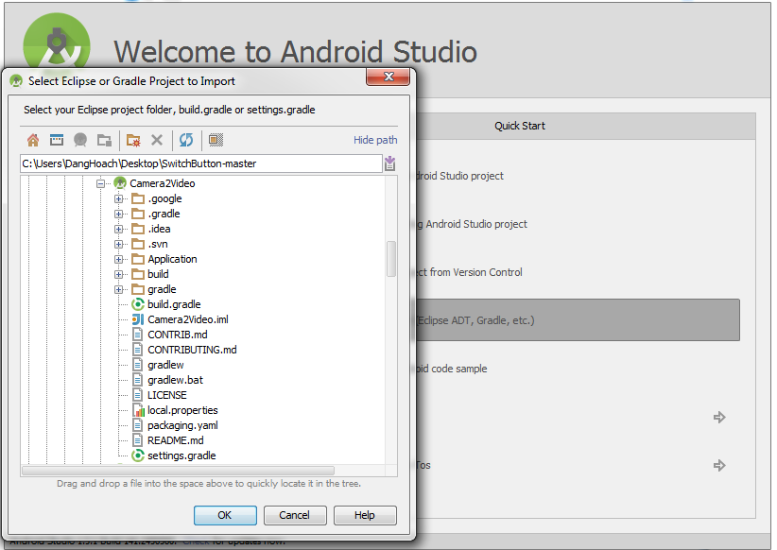

Structure Folder Project

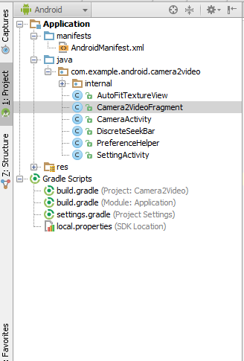

Build & Run Android Application

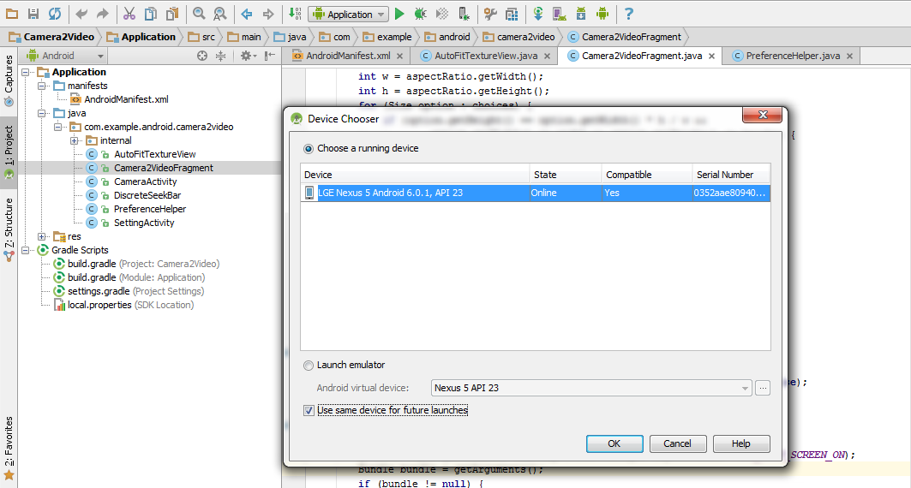

Class Explain:

SettingActivity.java => funtion Option Setting.

PreferenceHelper .java => Get Font or Back Camera

DiscreteSeekBar.java and folder internal => UI Seeker bar button

Camera2VideoFragment.java => Main class with all funtion

: